[](https://www.alertpest.co.uk/wp-content/uploads/2019/04/Checkatrade.png)[](https://www.alertpest.co.uk/wp-content/uploads/2019/04/CRRU.jpg)[](https://www.alertpest.co.uk/wp-content/uploads/2019/04/IPAF.png)[](https://www.alertpest.co.uk/wp-content/uploads/2019/04/NPTA.png)[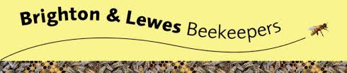](https://www.alertpest.co.uk/wp-content/uploads/2019/04/B-L-Beekeepers.jpg)[](https://www.alertpest.co.uk/wp-content/uploads/2019/04/Izettle.jpg)